1. Download Jmeter and extract zip folder

2. Go to bin folder and run jmeter.bat (or ApacheJMeter.jar)

Add Thread Group

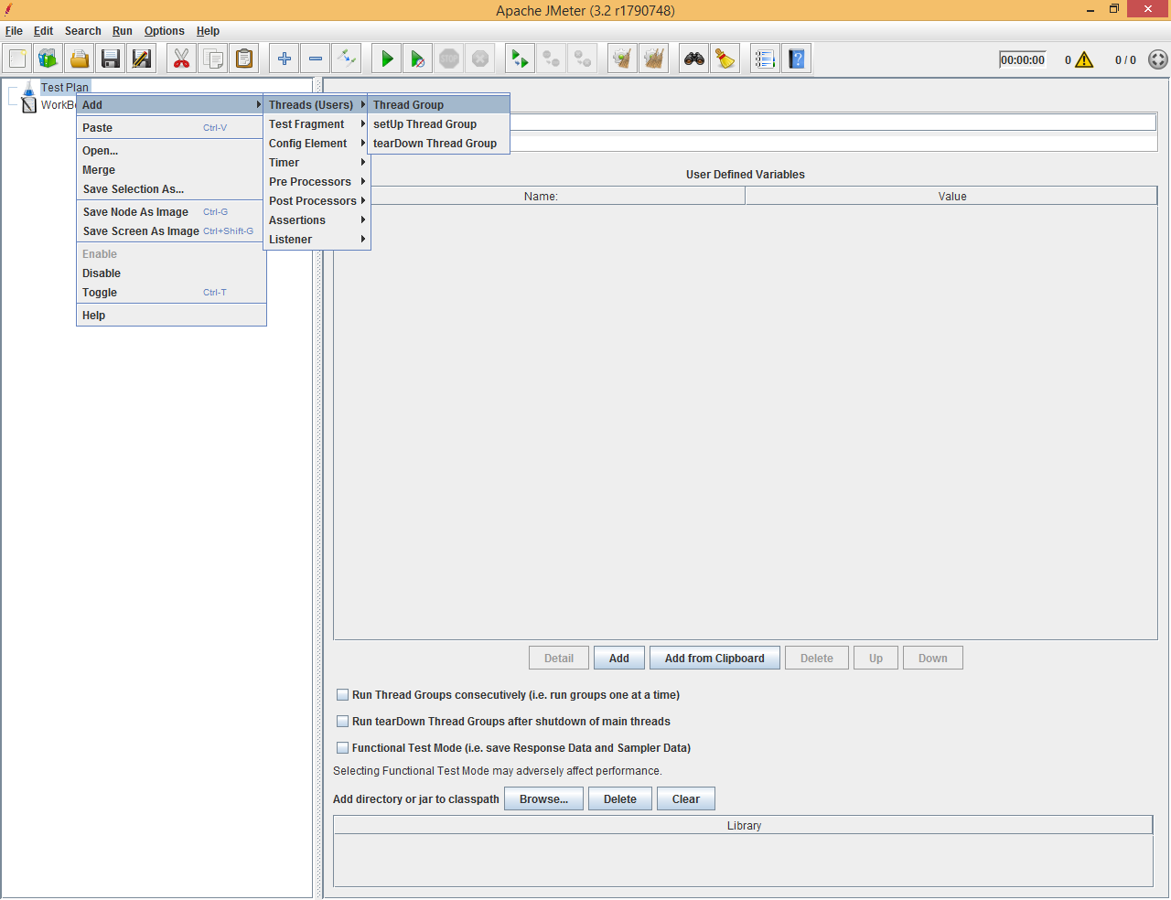

Add Bean Shell Sampler Under Thread Group

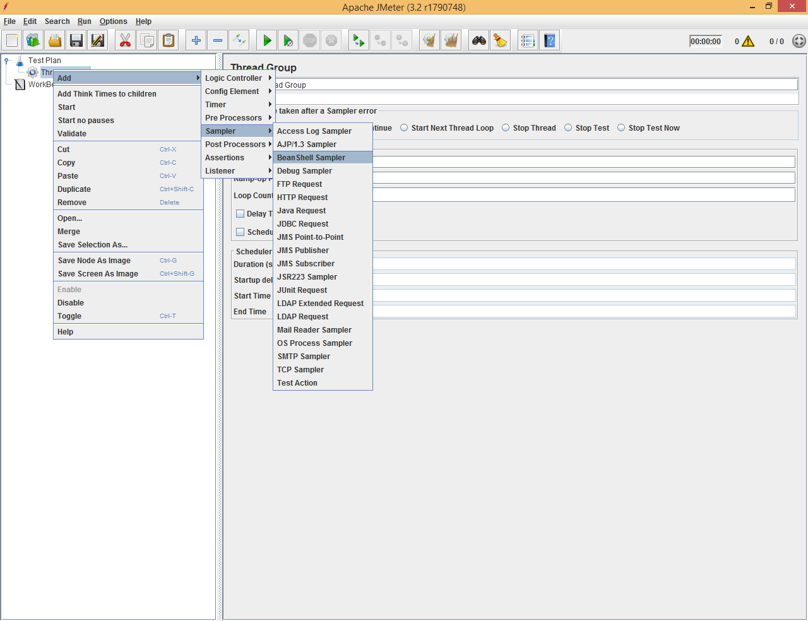

Add Http Request Default under Thread group

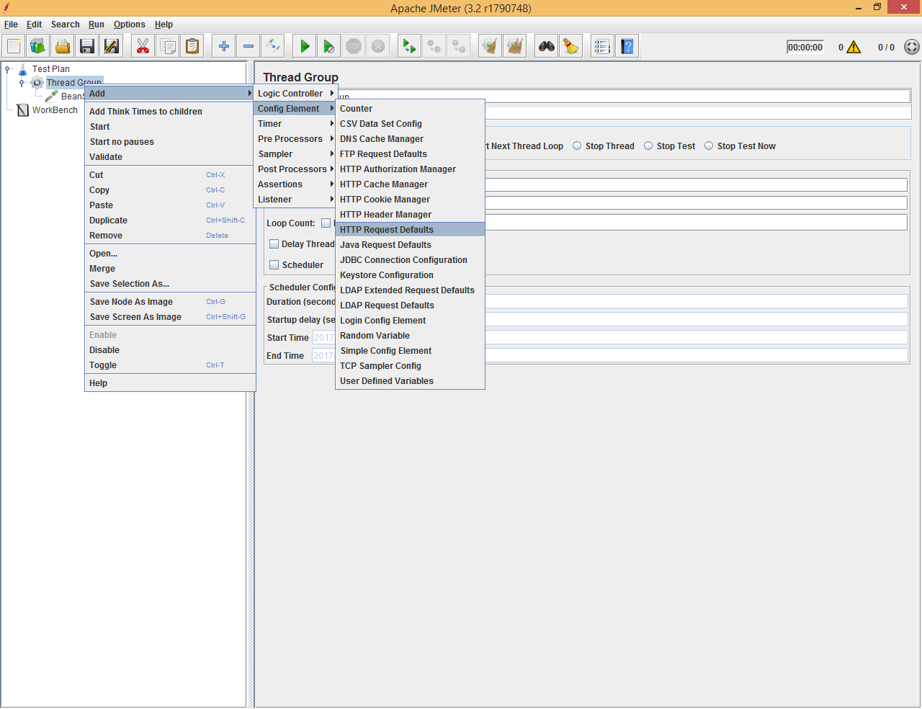

Add View Result Tree under Thread group

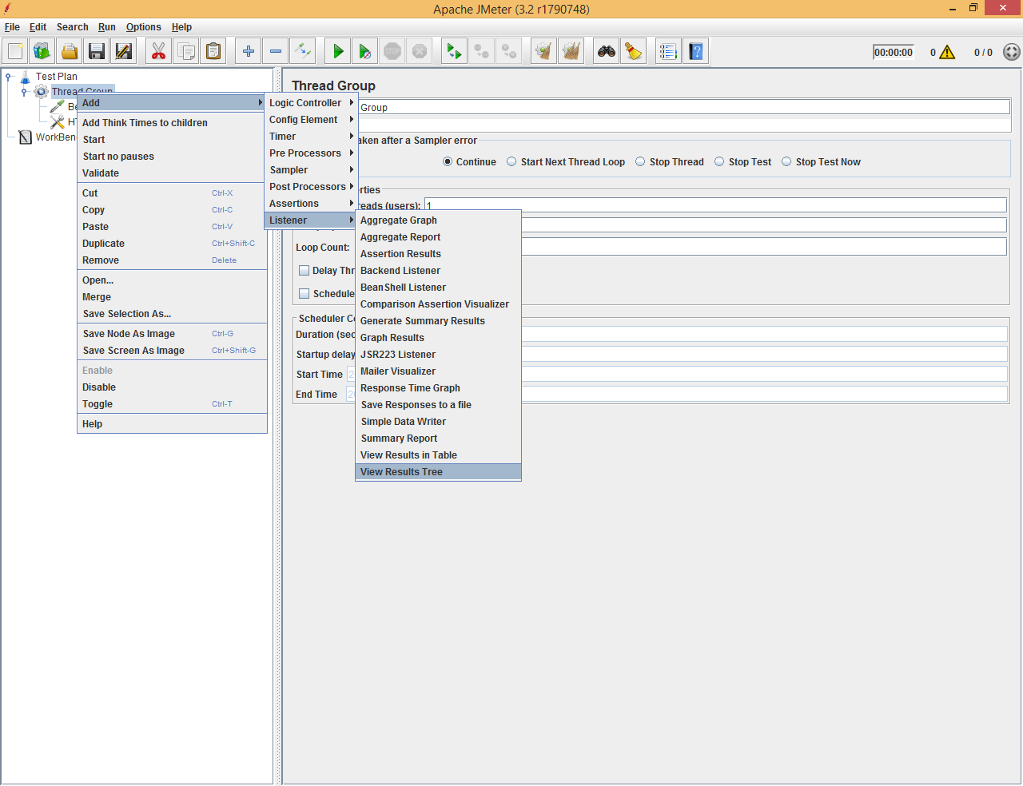

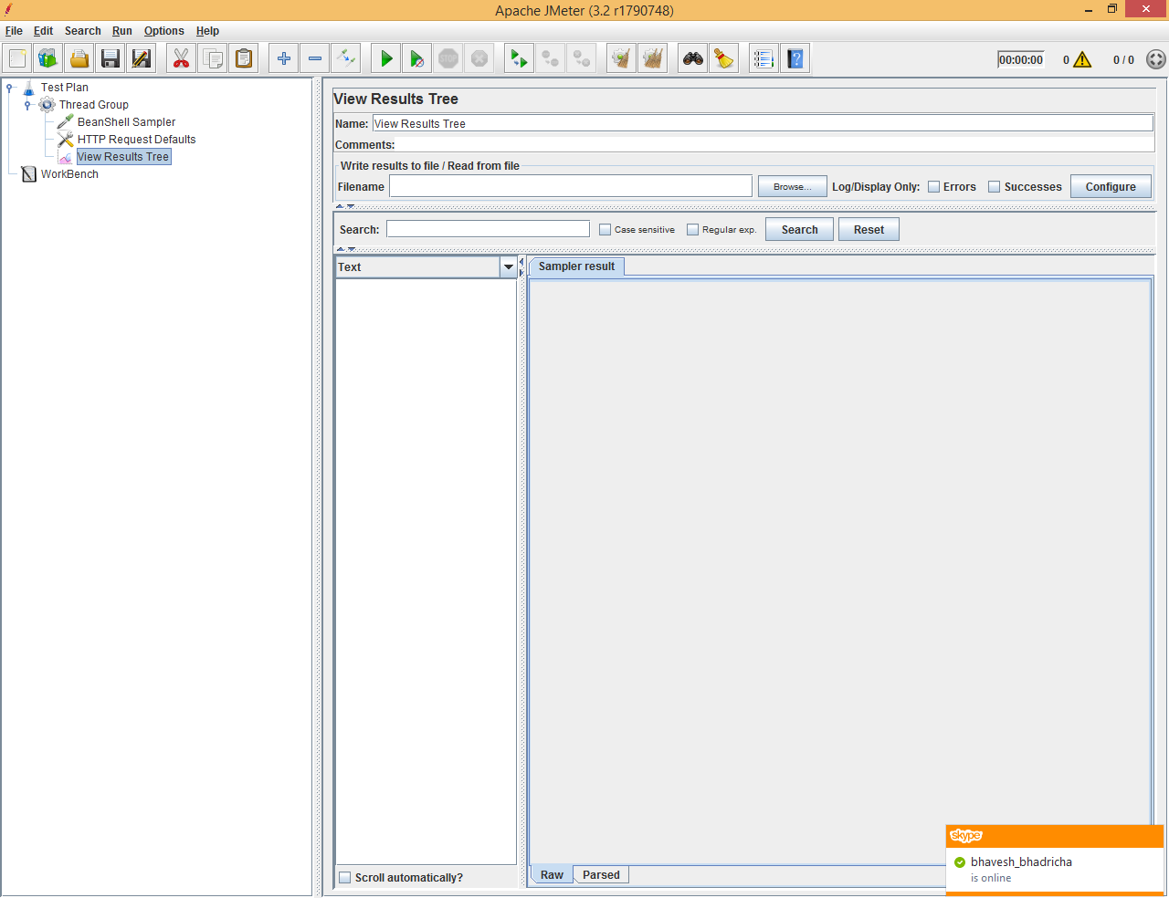

Rename them as appropriate

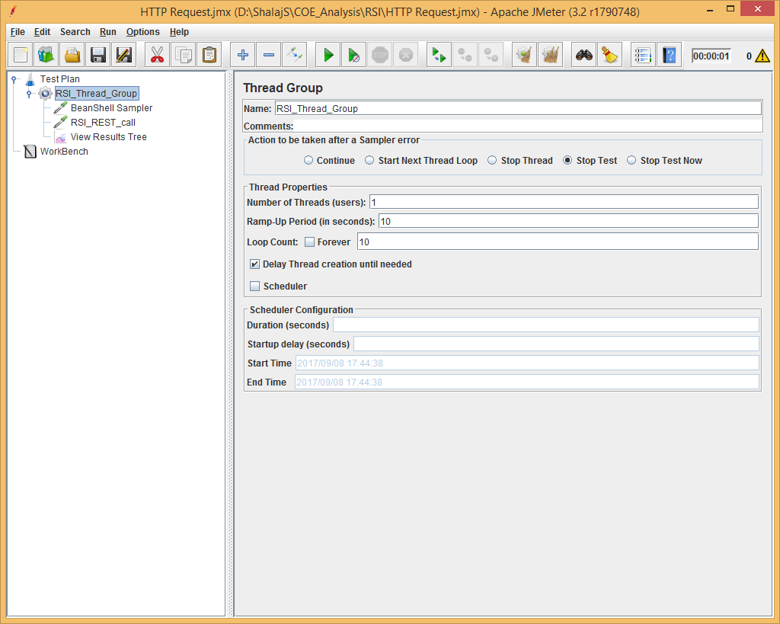

Now here we set 10 Loop counts that will send 10 Request at a time

Write BeanShell sample code that will generate random json variable

|  |
| --- |
| StringBuilder result = new StringBuilder();  Random random = new Random();  String [] nameArray = new String [] {"A","B", "C","D","E","F","G","H","I","J","K","L","M","N","O","P","Q","R","S","T","U","V","W","X","Y","Z"};  List list = Arrays.asList(nameArray);  String randomName = (list.get(new Random().nextInt(list.size())));  result.append("{");  result.append("\"id\" : ");  result.append("\"").append(random.nextInt(100)).append("\",");  result.append("\"name\" : ");  result.append("\"").append(randomName).append("\"");  result.append("}");  vars.put("json", result.toString()); |

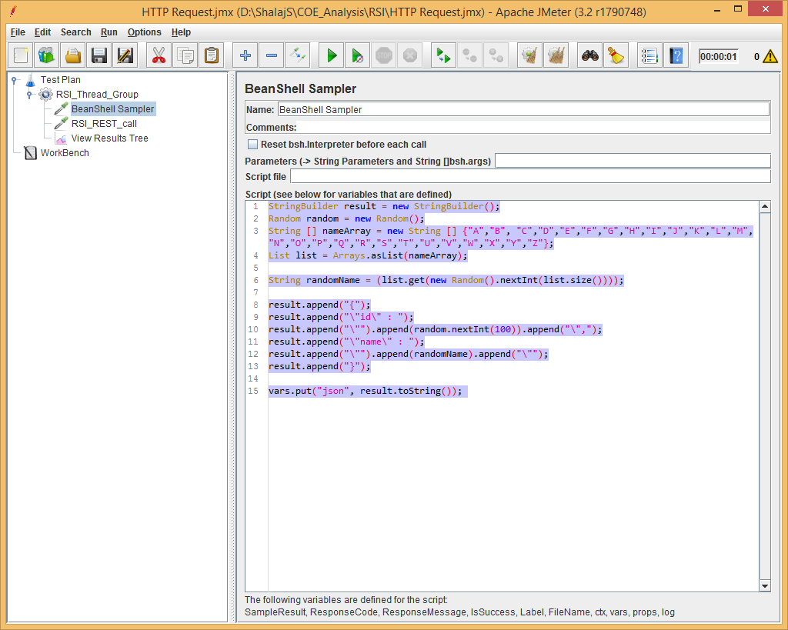

Specify host port and message under Http Request

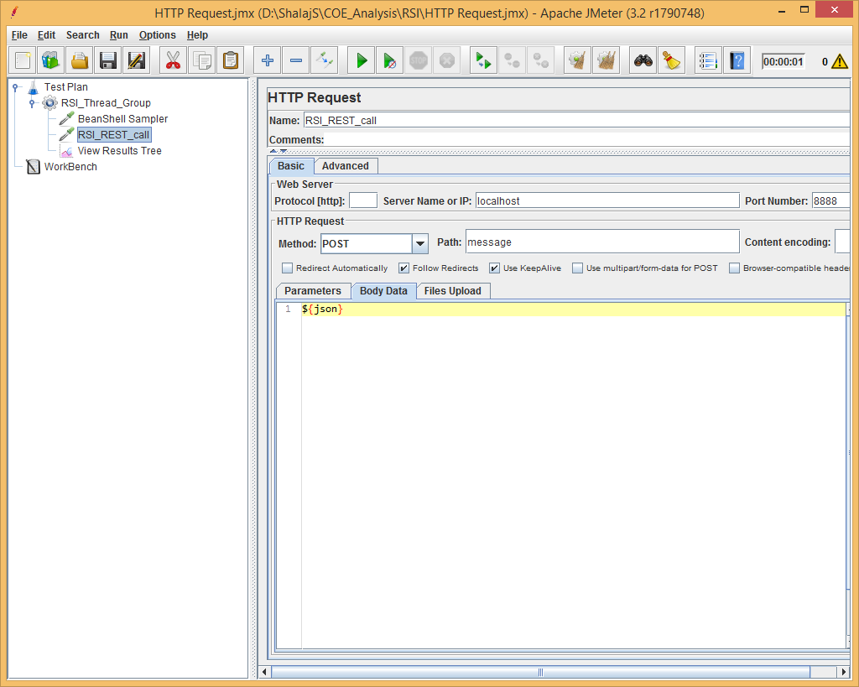

Here we are passing json variable that we set in BeanShell

Now start yours REST Sever that will handle these requests and run Thread group () and get the result under View Results tree